01 Introduction.

**What is NoSQL Database**

Databases can be divided in 3 types:

1. RDBMS (Relational Database Management System)
2. OLAP (Online Analytical Processing)
3. NoSQL (recently developed database)

**NoSQL Database**

* NoSQL Database is used to refer a non-SQL or non relational database.
* NoSQL database doesn't use tables for storing data. It is generally used to store big data and real-time web applications.

**History behind the creation of NoSQL Databases**

* the relational database was created by E.F. Codd and these databases answered the question of having no standard way to store data.
* relational database also get a problem that it could not handle big data, due to this problem there was a need of database which can handle every types of problems then NoSQL database was developed.

**Advantages of NoSQL**

* It supports query language.
* It provides fast performance.
* It provides horizontal scalability.

**Data Modeling in MongoDB**

* MongoDB collections do not enforce document structure.
* Always design schema according to user requirements.
* Do join on write operations not on read operations.
* Objects which you want to use together, should be combined into one document. Otherwise they should be separated (make sure that there should not be need of joins).
* Optimize your schema for more frequent use cases.
* Do complex aggregation in the schema.
* You should duplicate the data but in a limit, because disc space is cheaper than compute time.

**For example:**

let us take an example of a client who needs a database design for his website. His website has the following requirements:

Every post is distinct (contains unique title, description and url).

Every post can have one or more tags.

Every post has the name of its publisher and total number of likes.

Each post can have zero or more comments and the comments must contain user name, message, data-time and likes.

For the above requirement, a minimum of three tables are required in RDBMS.

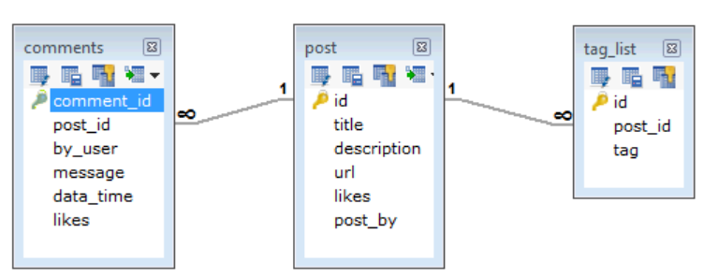

**But in MongoDB, schema design** :

**Database**

* Create Database 
* Drop Database 

**Datatypes**

**Collection**

**

**Documents**

* >db.COLLECTION_NAME.**insert**(document)  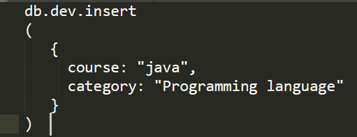
* MongoDBupdatedocuments A black background with white text

  Description automatically generated